## Product Sales Analysis

**Phase 1:Project Definition and Design Thinking**

**Project Definition:** The project involves using IBM Cognos to analyze sales data and extract insights about top selling products, peak sales periods, and customer preferences. The objective is to help businesses improve inventory management and marketing strategies by understanding sales trends and customer behavior. This project includes defining analysis objectives, collecting sales data, designing relevant visualizations in IBM Cognos, and deriving actionable insights.

It is detailed study of market potential performance to detect strengths and weaknesses. The gathering, classifying, comparing & studying of company‟s sales data, strictly speaking, gathering of sales data is not a part of analytical effort s but it substantially and vitally affects the quality of market potential.

Market potential provides additional information. For example that the increased sales volume came from product carrying a lower than average gross margin. Through sales analysis, management seeks insight on strong and weak territories, high volume, low volume products and type of customers providing satisfactory and unsatisfactory sales volume. It uncovers details that otherwise lie hidden in the sales record. It provides information that management needs to allocate sales efforts effectively. If sales management relies on the raw data, the result may be misleading. It depends solely on summary of the sales data. It has no way to evaluate the effectiveness of its own activities and those of the sales force if we say that sales have gone up by 5% over previous year‟s with 1% decline profit.

Market potential provide the management with additional information make an indepth study of why the margin is insufficient though sales management seeks insight on the sales territories with the most satisfactory and the least satisfactory sales volume .Market potential will then uncover significant details why it is so. It provide necessary information, management need in order to allocate future sales effort effectively. The role of sales manager in market potential is to make a detailed analysis of the available data ad use them properly to initiate action.

The sample selection process requires the form of sample be specified. For this purpose, researcher has subjectively decided which particular group will be part of the study. In a sample survey a small part of the entire population is subjected to the research. This sample is considered to be the true representative of the entire universe and decided upon certain criteria.

Data for market potential : Market potential is nothing but to collect, classify, study the company sales data. Collection of data is not part of analytical part, but it vitally affect the quality of the sales analysis. Market potential is generally based on data already in existence. It is called secondary data. Secondary data may be gathered either from internal sources such as invoice or shipping records or from external sources such as marketing research agencies, government agencies, trade association and trade journals. Secondary data are often readily available but their use should be with caution.

The sales management has to rearrange them according to their needs. Himalaya Drug Company maintain their internal sales records in some detailed manner showing individuals sales, sales by products, by classes of customers, by size of order and other pertinent break downs of sales data. Data are sometimes especially collected for the purpose of finding the market potential. This may be called primary data and may be collected under the control of sales management according to its needs. The main purpose of market potential is to convert raw sales data into actionable information for sales manager.

The process involving editing, tabulating and cross tabulating and also breaking them down into various way to make them comparable. When the sales planning is done, the sales manager finds out the potential market. Sales manager collects the information and analyses it and then compare the actual one with standards. An evaluation program review both the nature and extend of sales force efforts and influence of external variables, once the degree of influence of controllable and uncontrollable factors are determined. Sales management can decide whether to corrective action or to revise the sales plan or both.

**MARKET SIZE**

India to have that with the greater digital adoption, the Indian healthcare market, which is worth about $ 200 billion, will grow at a compound annual rate of 28% up to $ 280 billion by 2025. The health care market can increase upto four times to $ 472 billion in 2025. India experience 28-32% growth of the medical industry is expected to double from today (April 2017) from $ 5 billion to $ 20 billion from r. By 2020. Medical tourists in India have increased by more than 50 percent to 200,000 in 2016 from 130,000 in 2015 The healthcare information technology market is currently valued at US $ 1 billion (April 2016) and is expected to increase 1.5 times by 2020. More than 80 percent of the antiretroviral drugs used worldwide to fight Acquired Immune Deficiency Syndrome (AIDS) are provided by Global pharmaceutical companies. A total of 3,598 hospitals and 25,723 dispensaries across the country offer AYUSH treatments (Ayurveda, Yoga and Naturopathy, Unani, Siddha and Homeopathy), thus ensuring the availability of alternative medicines and treatments for people. In 2017, the Indian government granted subsidies for the establishment of AYUSH educational institutions in the states and territories of the Union.

**COMPANY PROFILE**



The Himalaya Drug Company is an Indian company established by M Manal in 1930 and based in Bengaluru, Karnataka, India. It produces health care products under the name Himalaya Herbal Healthcare whose products include ayurvedic ingredients. It is spread across locations in India, United States, Middle East, Asia, Europe and Oceania., while its products are sold in 92 countries across the world. The company has more than 290 researchers that utilise ayurvedic herbs and minerals. A Hepatic drug, named Liv.52, is its flagship product, first introduced in 1955. Liv.52 to date has now over 215 clinical trials backing it. Himalaya Global Holdings Ltd. (HGH), is the parent of The Himalaya Drug Company worldwide. It is also the global headquarters of all Himalaya subsidiaries. Founded by M Manal , the company was founded to commercialize the roots and herbs products being used in natural form earlier. Today, the company has offices across the globe, including India, USA, South Africa and other countries in Europe, Middle East, and Asia. Global markets . As of 2015, the company sold its products in 91 countries with about 50% of its revenue from outside India.

Products

Himalaya Herbal Healthcare has a very wide range of products, which include "pharmaceuticals, personal care, baby care, well-being, nutrition and animal health products."The Neem Face Wash is one of their most popular and well known products. Mother care products have been launched in 2016 with foray into extensive research and development in systems of ancient Ayurveda medicines of India. The company has a presence in 92 countries.

History of Himalaya:

Eighty years ago, on a visit to Burma, Himalaya’s founder, Mr. M. Manal, saw restless elephants being fed with a root to pacify them. The plant from which this was taken is Rauwolfia serpentine. Fascinated by the plant’s effect on elephants, he had it scientifically evaluated. After extensive research, Serpina, the world’s first anti-hypertensive drug, was launched in 1934. This legacy of researching nature forms the foundation of Himalaya’s operations. Himalaya uses the tools of modern science to create pharmaceutical-grade ayurvedic products. We have pioneered research that has converted Ayurveda’s herbal tradition into a complete range of proprietary formulations dedicated to healthy living and longevity. Today, these products have found acceptance with medical fraternities and serve the health and personal care needs of consumers in 67 countries.

PRODUCT & SERVICES

Himalaya’s products can be broadly classified into 3 main ranges viz. Healthcare Health maintenance, eye care, skin care, cardiac care, immune booster and cough control Personal Care Health care, oral care, hair care, skin care and baby care Animal Health Daily care products for sensitive cats and dogs Each of the products under the categories mentioned above are ayurvedic and have no side effects after use.

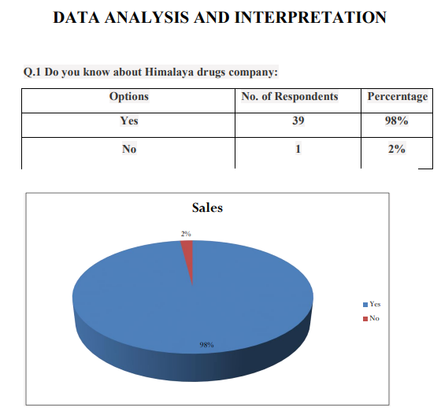

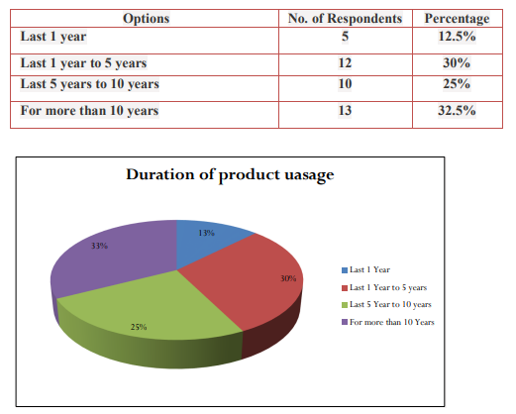

Q3What are the reason that higher prices may not affect consumer buying?

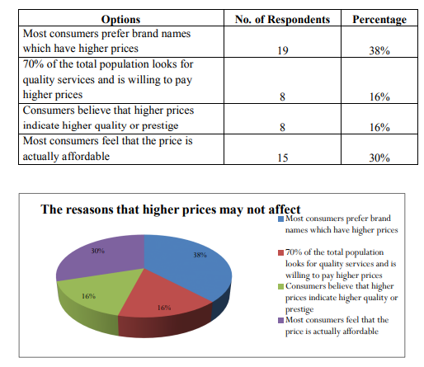

**CONCLUSIONS**

1) Customers get value for their money when they purchase a product or on service rendered.

2) The Himalaya Drug Company is eyeing the organic segment for personal care products in India with its Botanique brand, a readymade body care range catering to international markets.

3) Customer are satisfied with the brand, availability and price of the Himalaya products. Its reputation is for clinically studied, pure, and safe herbal healthcare products that are based on extensive scientific validation and straighten quality controls.

4) Last year, the segment contributed around 40% to turnover. Himalaya has a market share of around 19%, ahead of brands such as Garnier, Clean & Clear and Ponds. Conclusion of Hypothesis

5) We accept the first hypothesis, customer prefer Himalaya products more because of their trust over the company.

6) We accept the second hypothesis, from the survey it is concluded that market share of Himalaya is more than its competitors.